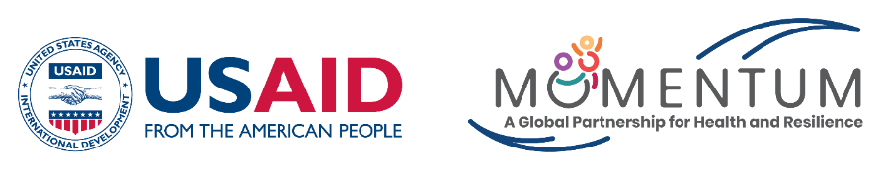

USAID’s MOMENTUM Country and Global Leadership:
India-Yash Fellowship Program

Eligibility Criteria
- Age: 20-29 (could be relaxed for vulnerable communities)
- Education: Graduation in any stream (could be relaxed for vulnerable communities) 2 years of experience in any area
- Willingness to layer SRH inputs to their existing body of work in the domain of climate change, prenatal sex selection, contraception, male engagement, mental health, demographic transition
- Applications from candidates engaged with youth forums, networks, civil society organizations, corporates, CSR, social enterprises will be encouraged
- Geographical location: Working in any of the 5 priority states, i.e., Madhya Pradesh, Chhattisgarh, Jharkhand, Assam and Odisha
- Candidates from marginalized communities
- Candidates who do not have prior exposure to such fellowships/trainings Openness to travel and being in the field Language and other skills
- Working knowledge of English is mandatory as the classes would be held in the combination of English & Hindi (if required) language but the knowledge products would be developed in English only. However, our team will support to edit the products before finalization.
- Knowledge of MS Windows (Word, Excel and PPT) would be preferable, although not mandatory

